***SCD Type 2***

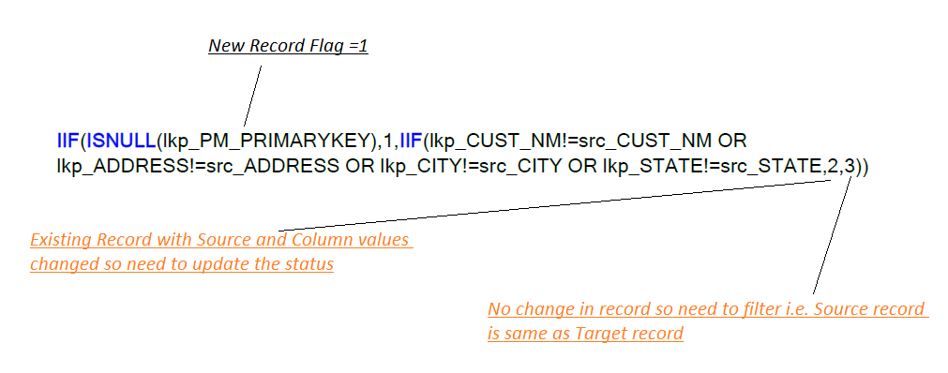

From the above condition if any record flagged as 1 that means it new record which is coming from source and this is not available in target.

If any record flagged as 2 that means it’s already exists in target and there is a difference in attributes from source and target.

If any record flagged as 3 that means this record present in source and target, there is no difference between attributes.